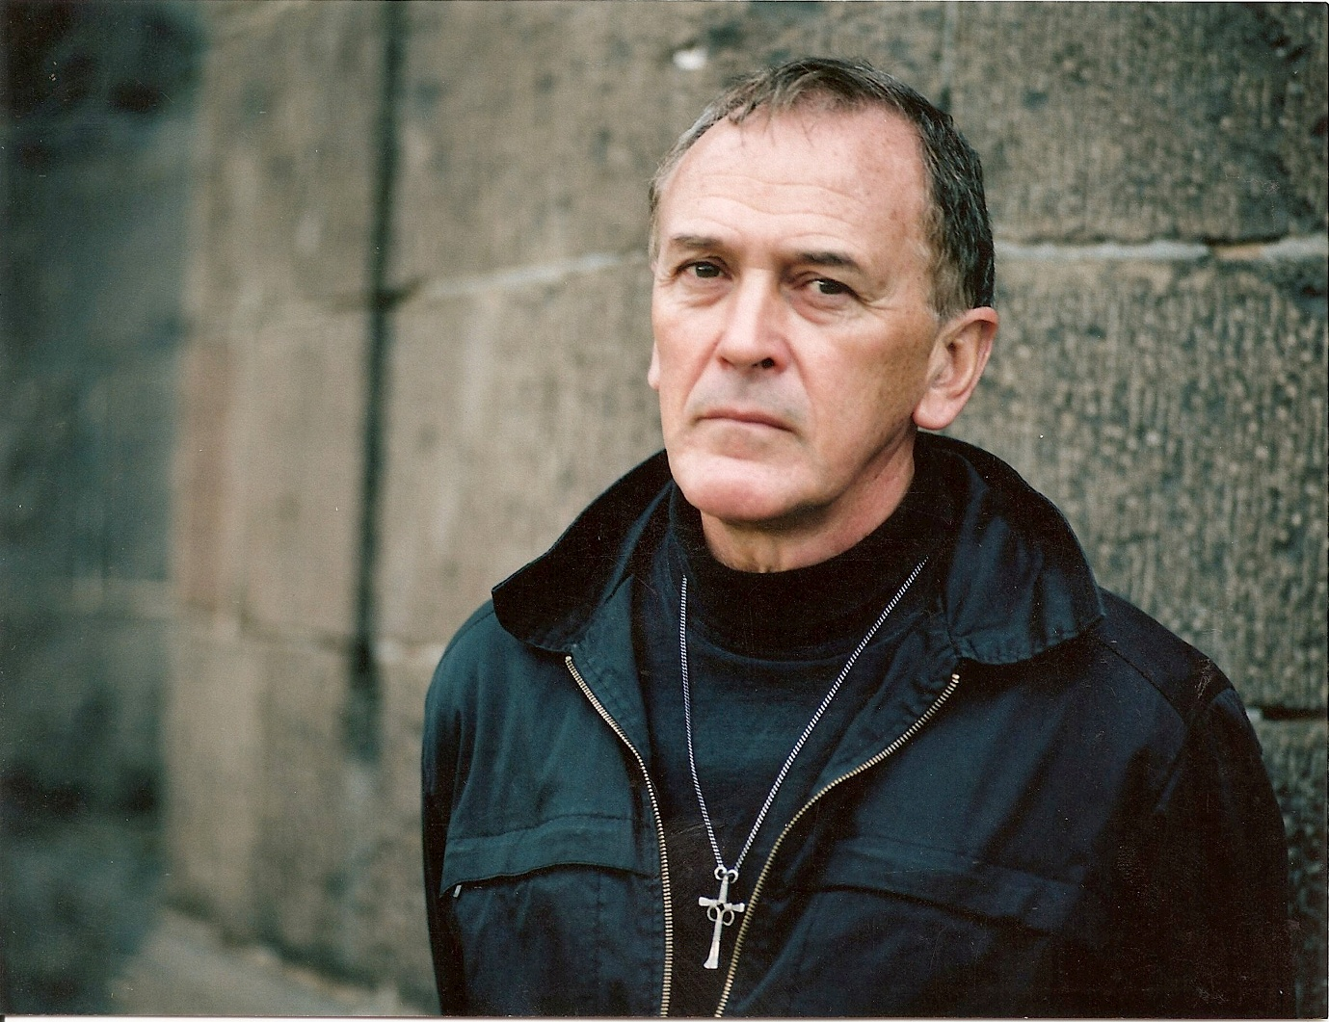
Professor Peter Norden AO, Expert Witness in Civil Law Matters
Do you believe that you may have a Civil Law Action Claim in relation to your arrest or detention that could be substantiated in a Court of Law? Now or after release?
Apart from good legal representation, your case will be stronger with an Expert Witness.
With many years direct experience inside Pentridge and Barwon Prisons in Victoria and recent Expert Witness Reports in Civil Damage Cases in Queensland, NSW, Victoria & Tasmania, Peter Norden will bring his wide experience and expertise to support your Civil Action Claim involving Police or Prison Authorities: Public & Private.
With his broad on the ground experience complemented by a master’s degree in human rights law and a master’s degree in social work, Peter has had a 100% success rate to date in every case he has been asked to support in Civil Legal Actions across Australia.
Ask your legal representative to consult with Peter to support your Civil Action Claim.
In 2016, Peter was made a Fellow of the Australian & New Zealand Society of Criminology for his contribution to the Australian criminal justice system over a period of forty years. As a Vice Chancellor’s Fellow in the Melbourne Law School, an Honorary Fellow and Honorary Doctor in Criminology at Deakin University, Peter Norden can provide the expertise and direct experience required to support your civil action claim.
In 2017, Peter was recognised as an Officer in the Order of Australia: For service to community development through social research and programs aimed at assisting marginalised young people and offenders, and to the mental health sector throughout Australia. EMAIL: peter.norden@deakin.edu.au
www.nordendirections.au www.justicereforminitiative.org.au www.seekingjustice.au

